**Gebze Technical University**

**Computer Engineering Departman**

**CSE 436 Digital Integrated Circuit**

**Homework #1**

**Berkan AKIN**

**171044073**

* In accordance with the request, two designs have been created. First, a design with 4λ/2λ NMOS and PMOS transistors was made, and then an 8λ/2λ PMOS transistor was designed. The two different inverters that have been designed are shown below..

**4λ/2λ NMOS and PMOS**

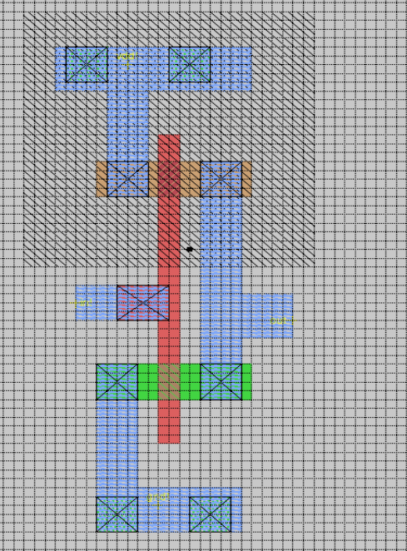

**4λ/2λ NMOS and 8λ/2λ PMOS**

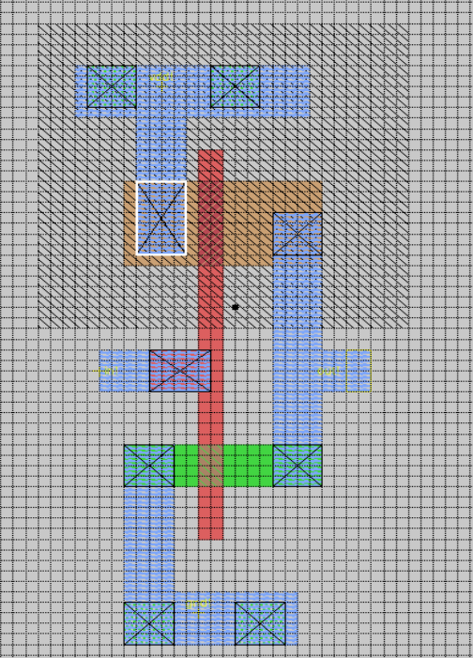

* Two different transistors have been tested with NG Spice, and the test results are presented below.

**4λ/2λ NMOS and PMOS**

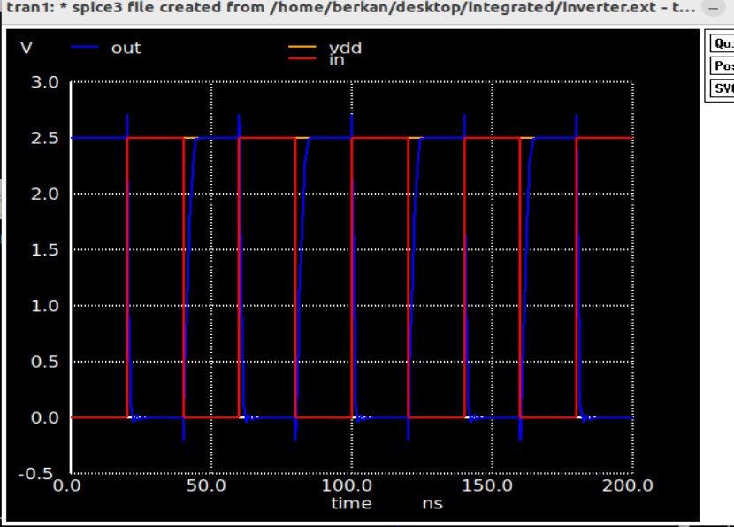

**4λ/2λ NMOS and 8λ/2λ PMOS**

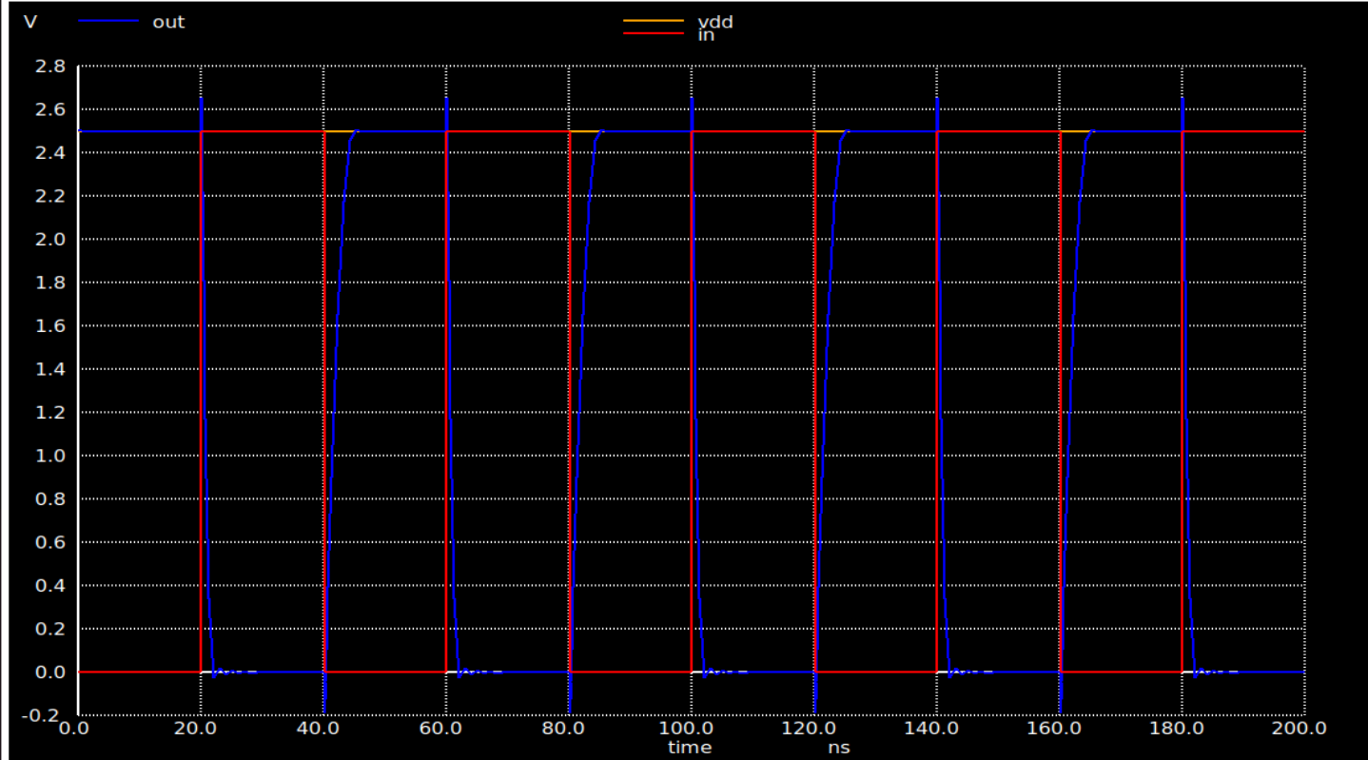

* When the response times of the two inverters are compared, it is observed that the inverter made with the 8λ/2λ PMOS transistor has a delay. The delay can be seen in the comparative image below. The inverter on the right has an 8λ/2λ PMOS, while the one on the left has a 4λ/2λ PMOS

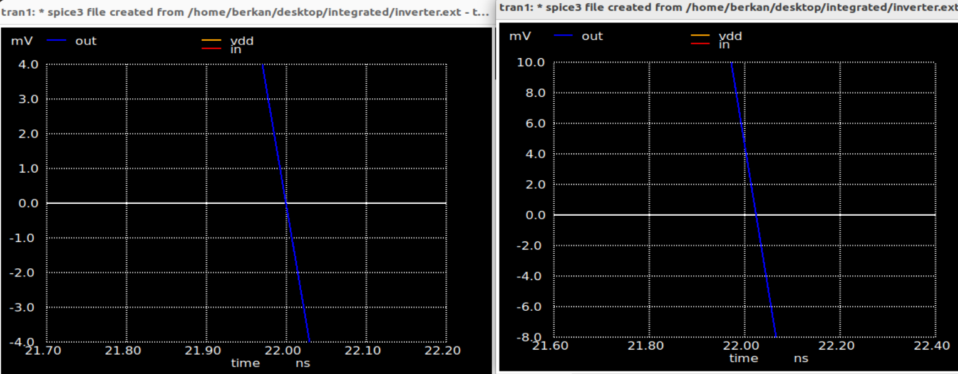

* The delay on the left with the 4λ/2λ is less, while on the right with the 8λ/2λ, the delay is more apparent.

